THYME Project

Teesside, Hull and York Mobilising Bioeconomy Knowledge Exchange

Proof of Concept Scheme
Overview

Staff at the THYME Universities can apply for up to 50K to fund proof of concept projects that address one of THYME’s three Grand Challenges areas. Each project must involve a minimum of two of the THYME project universities and an industrial partner. The projects can be up to a maximum of 12 months.

The THYME Project Grand Challenges are:

1. Production of high value products from biowastes and by-products
There is an opportunity for the region to become a world leader in the conversion of bio-based waste to higher value chemicals with multi-billion pound markets. Waste, particularly urban organic waste, is a global issue and development of technology and business models is a major opportunity for both inward investment and as an exportable capability. The region has the science base and the industrial absorptive capacity to become a world leader in the field.
2. Re-purposing of industrial sites for bio-based manufacturing
The THYME Project will explore opportunities to re-purpose existing industrial sites into those for processing bio-based raw materials and manufacturing bio-based products. The region has a wide range of opportunities in this area and projects that seek to evaluate these sites and generate plans for future development are sought.
3. Increasing productivity of bio-based processes
Innovation offers a wide range of opportunities to increase the productivity of bio-based processing, particularly by sharing technology between sectors. The THYME Project will bring together expertise at Teesside, York and Hull to address a range of productivity bio-based processing challenges. The opportunities for increasing productivity are extensive and include reducing waste; adding value to by-products, automating manufacturing processes; reducing energy and material inputs, developing better enzymes, vaccines, antibiotics and processing micro-organisms; adapting feedstocks and introducing one pot processes.
These Grand Challenges can include projects that support bioeconomy growth through the use of gaming, artificial intelligence, virtual reality and augmented reality.

Funding available

We will support projects up to a maximum of £50K.

The PoC Scheme will fund translational projects at TRL 3 or above and will pay 100% of direct costs, e.g. staff salaries, consumable and travel, but not overheads. The funding is available for projects up to 12 months. If in doubt, please contact your THYME Project Manager or Thyme-project@york.ac.uk regarding eligibility.

Project Review and Acceptance

All proposals will be reviewed and judged for relevance to the THYME grand challenges, as well as individual technical merit. We expect that decisions will be made within one month of application, and that projects will start within three months of award, unless by prior agreement.

Deadline for applications

The THYME Project expects to run a 3 year programme of Proof of Concept projects depending upon the level of demand. The second deadline for applications will be 12 noon, 6th September 2019. Applications should be submitted by email to Thyme-project@york.ac.uk

Monitoring and Completion of the project

A 6 month Project Progress Report and claim will need to be submitted by the lead THYME partner. A Project Closure Report will need to be submitted to THYME outlining the full POC spend, outcomes, outputs and deliverables of the project.

SECTION 1: SUMMARY

1.1 Title of Project (please include a short title or acronym)

1.2 Total funds requested (note: VAT exempt) |  | £

1.3 Lead Organisation Finance Contact Details
Organisation:
Contact name:
Contact details:

1.4 Main Applicant
Main Applicant Name:
Role/Job Title:
Contact details:

1.5 Co-Applicants Repeat this section as necessary. Note that formal correspondence will be via the Main Applicant.
Co-Applicant Contact Name:
Organisation:
Role/Job Title:
Contact details:

1.6 Start date of project: 1.7 End date of project (maximum 12 months):

1.8 Summary of proposal (200 words maximum). Non-confidential (this will be made publicly available along with the names of the partners involved).

SECTION 2: PROJECT OVERVIEW

2.1 Project Objectives (what are the project’s aims) Maximum 1 page
2.1

2.2 How will the project address the THYME Project’s Grand Challenges and contribute to driving HE-HE collaboration and sharing of best practice? Maximum 1 page
2.2

2.3 Proof of Market (demonstrate the established market need, What does the competitive landscape look like? Is any further market engagement required? If so please outline how some of the POC funding will be used to demonstrate a market need) Maximum 1 page
2.3

2.4 Project Outputs (what will the project deliver?) Maximum 1 page
2.4

2.5 Project Outcomes and Indicators (in what ways will the project be of value to the identified beneficiaries, and how will the outcome be measured?) Maximum 1 page
2.5

2.6 Sustainability (how will the work continue and be developed further, once the project is complete) Maximum 1 page
2.6

2.7 Upon completion of the work what will the technical readiness level (TRL) be? Please provide a frank assessment of what the effect of PoC funding will be in terms of progressing the technology nearer to commercial application and to market. Also refer to the figure below to establish the TRL. Maximum 1 page
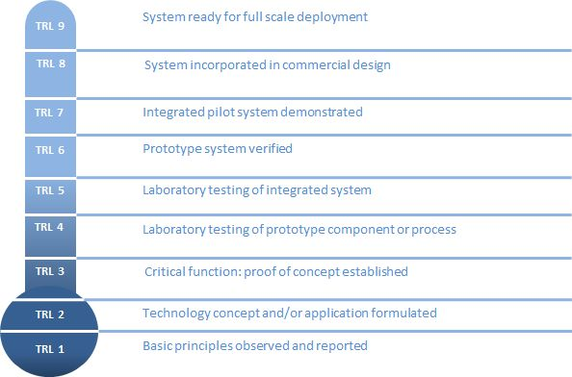
2.7

2.8 Project Partners (list any non-THYME Project organisations that will be involved in the project and what their role will be) Maximum 2 pages
2.8

SECTION 3: PROJECT PLAN

3.1 Project Plan (what are the main phases and tasks of the project, and which organisation is involved in each?) Maximum 2 pages

3.1

3.2 Ethical issues (explain any ethical issues raised by the project and how they will be addressed) Maximum 1 page
3.2

3.3 Risks Indicate severity and the measures undertaken to reduce impact of any risks that the project could entail. Examples might include research risks, personnel risks and financial risks.

Risk Id | Risk Description | Likelihood (Low, Medium, High) | Severity  (Low, Medium, High) | Mitigation

3.4 Intellectual Property State the IPR position in relation to this opportunity Maximum 1 page
3.4

SECTION 4: PROJECT BUDGET

4.1 Funding requested:

 |  | Cost Basis | Total
Staffing
Consultancy

Equipment
Costs

Materials and Consumables

Other Expenses

Travel and subsistence costs

Total

Cost basis indicates a unit cost, as appropriate, e.g. for consumables. Please provide an expected breakdown of costs by calendar quarter as an Appendix.

4.2 Industry contribution Please include costed details here of any industry contribution, including but not limited to: in-kind contributions (staff time, equipment use, consumables, etc); cash contributions to the project, etc.

4.2

5. Main Applicant’s signature:
 | Signature | Name | Date
Main Applicant |  |  | dd/mm/yy

6. Endorsement:
 | Signature | Name | Date
Head of Department

